LIFE SAVER BLOOD BANK MANAGEMENT SYSTEM

**ABSRTACT:**

According to the American Association of Blood Banks as of 2013, about 36,000 units of blood are needed every day. There are many cases where blood is not available for needy in critical condition, there may be a situation where donor is not available. There are already blood banks which connect donors, receivers, But to check availability of blood samples we need to visit many blood banks until we get required sample. We came up with a solution for providing e-website which shows current availability of samples, connect register donors, receivers.

**Problem Statement:**

Methodology:

The aim of the project is to develop a web application for blood bank management where the availability of blood is provided. The main objective of this website is that:

🡪To provide a basic information about the blood types and facts about blood.

🡪To maintain the records of register, donor, and the availability of the blood stock.

🡪To connects the receiver and the donor.

Registration:

The primary step to check the availability is the signup form. Once you Register to the website it redirects you the content page.

Login:

Once you register to the website, in order to check the stock and to register for donor and receiver, you can just simply login to the website.

Data Input:

The user has to fill the form in order to receive or donate for the blood. Our database stores the user details for easy administration.

Architecture:

Software and Hardware Used:

Software: Wamp64, Notepad++

Languages used:

frontend: html, css, javascript.

backend: sql, php,

Hardware: Intel i5 processor (8GB,1TB)

**Technical Description:** This project has 4 phases

1)One can sign up and access our website information.

2)One can donate blood by donor registration. Donor details will be saved for future purposes

3)One can get required blood sample by receiver registration. Blood sample required will be allocated for receiver.

4)our current availability of blood sample is displayed all the time.

**Source Code:**

This is google drive link of our project:

<https://drive.google.com/drive/folders/1ELYHOJNwXXjVoKy2QDhUvrM8I_NDcFyy>

**Process Diagram:**

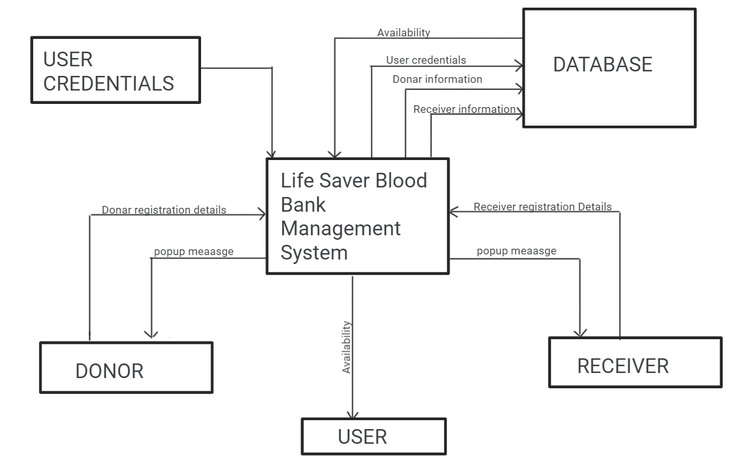

**Performance:**

Our website home page:

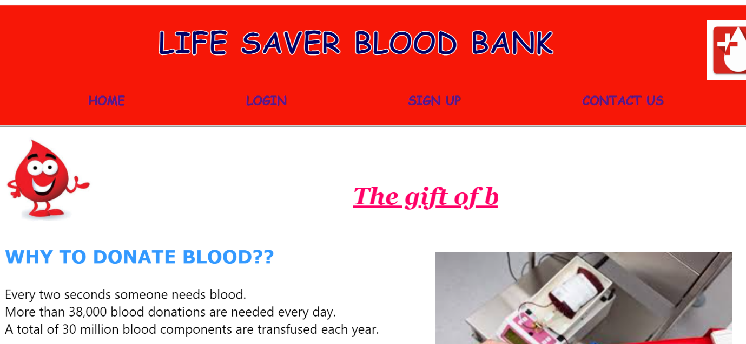

Login page: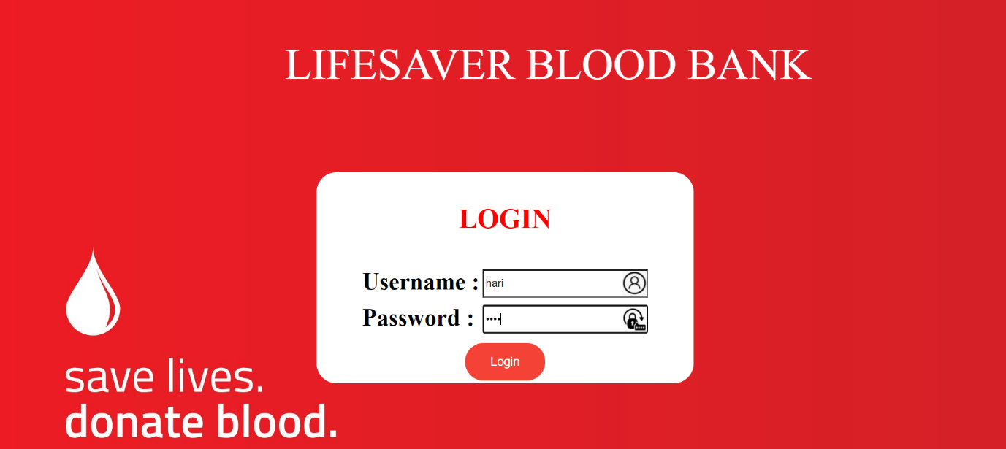

Our functionality page:

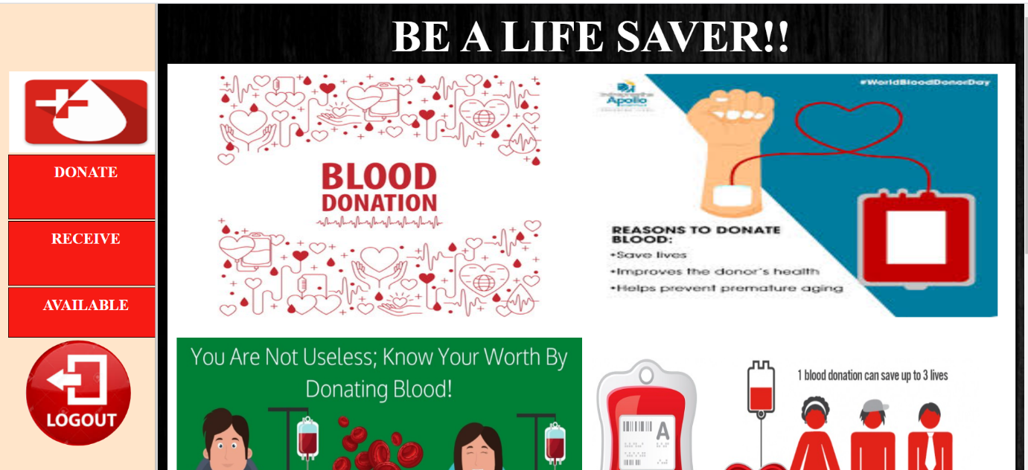

Our receiver registration page:

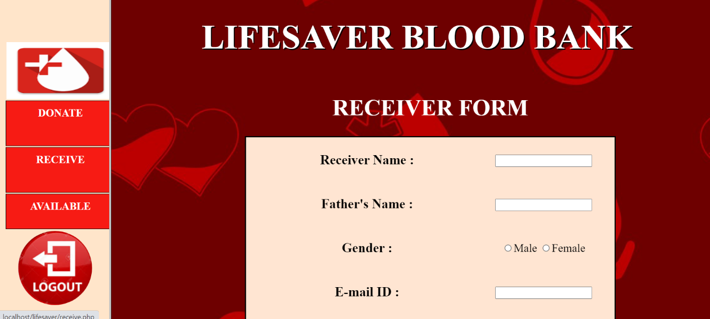

Donor Registration page:

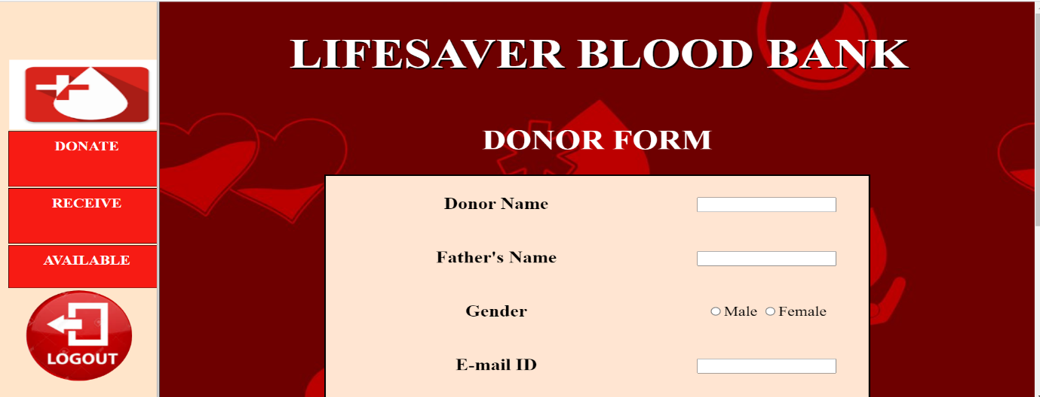

Contact us page that provides our social media links,address

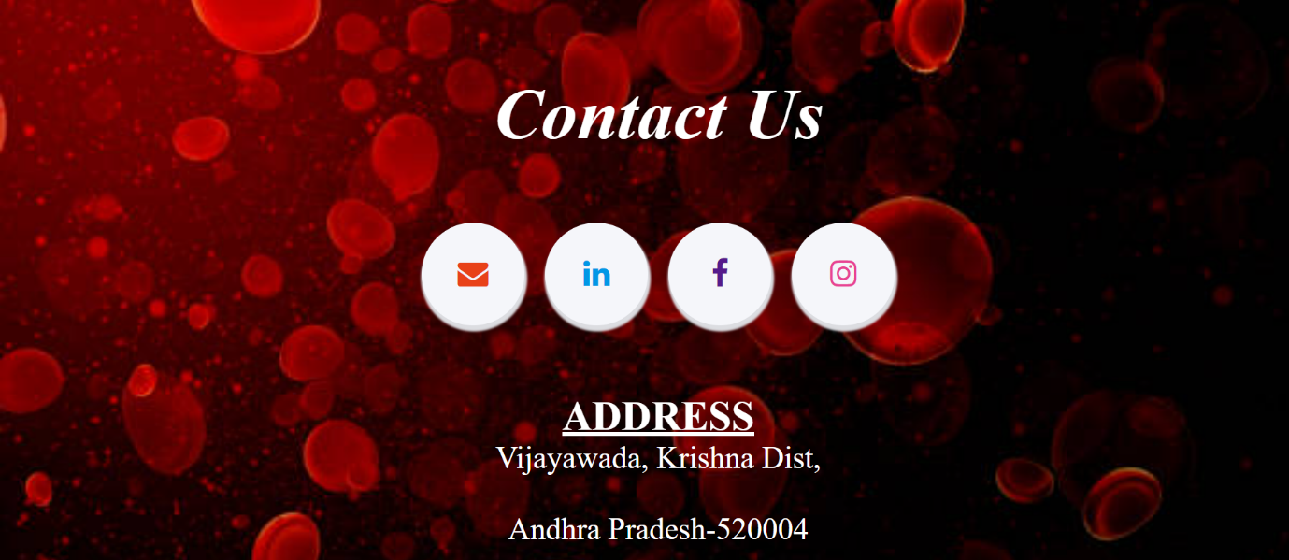

Our databases:

We have stored details of users using WAMP Server.Using php language we done scripting.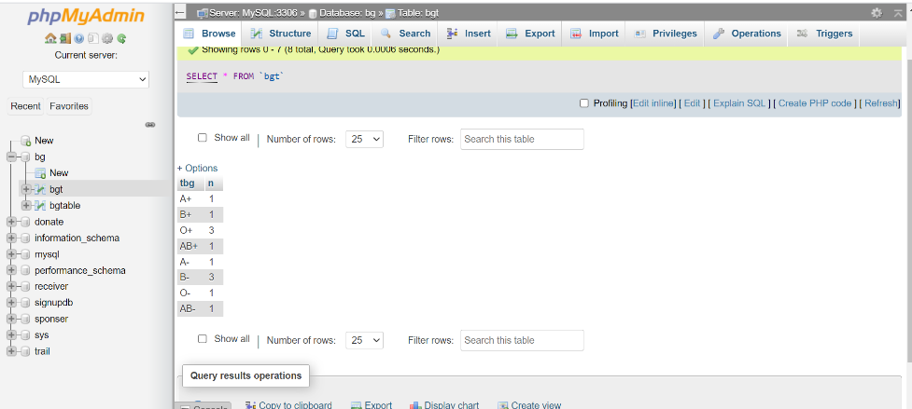

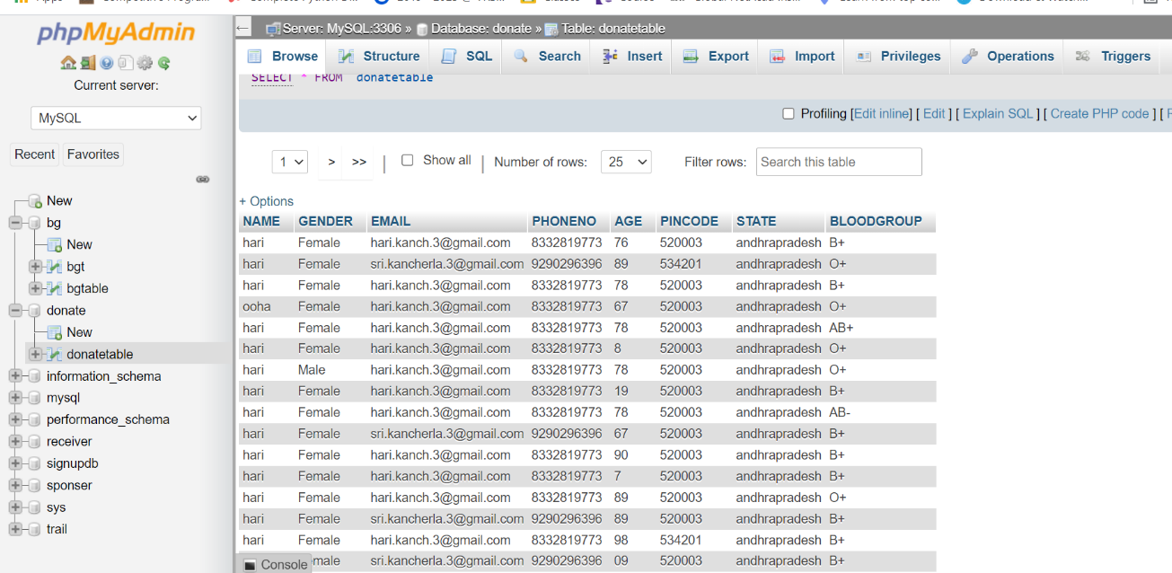

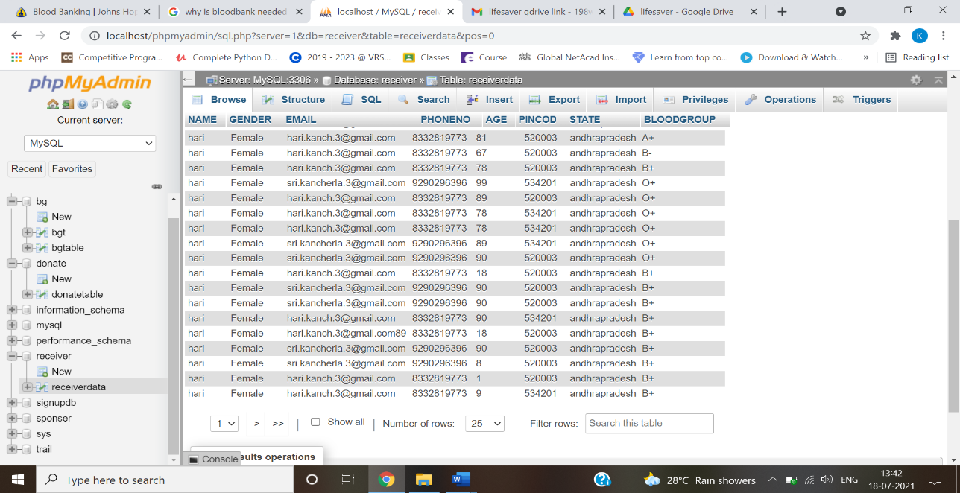

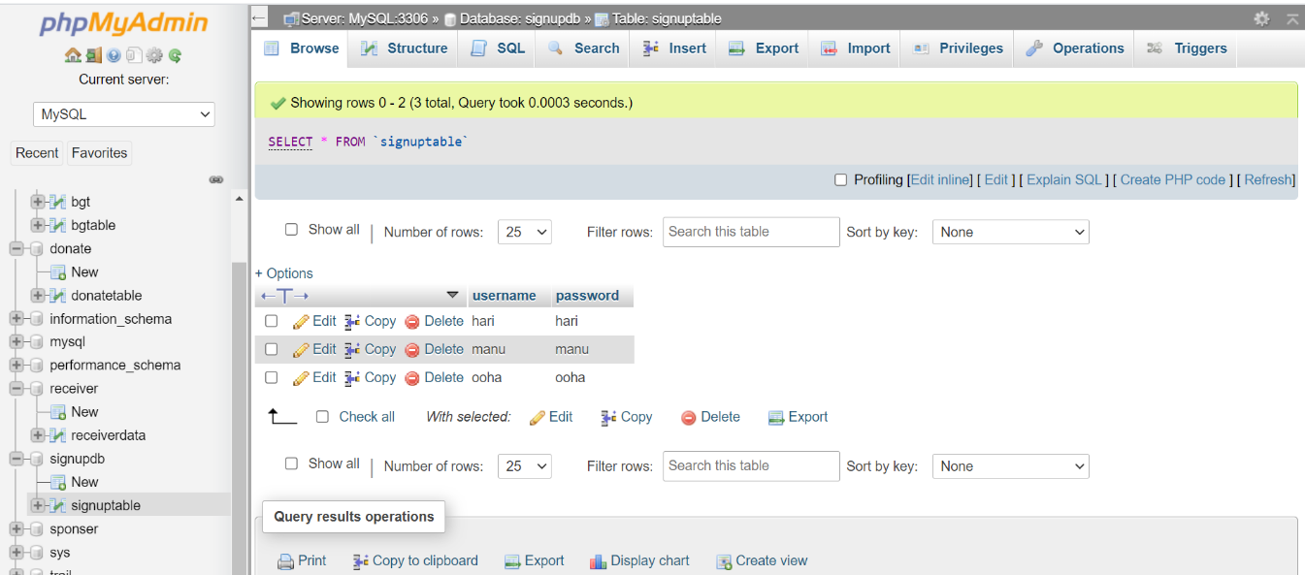

**Results:**

Our website shows updated availability of blood samples for everyone at any time.

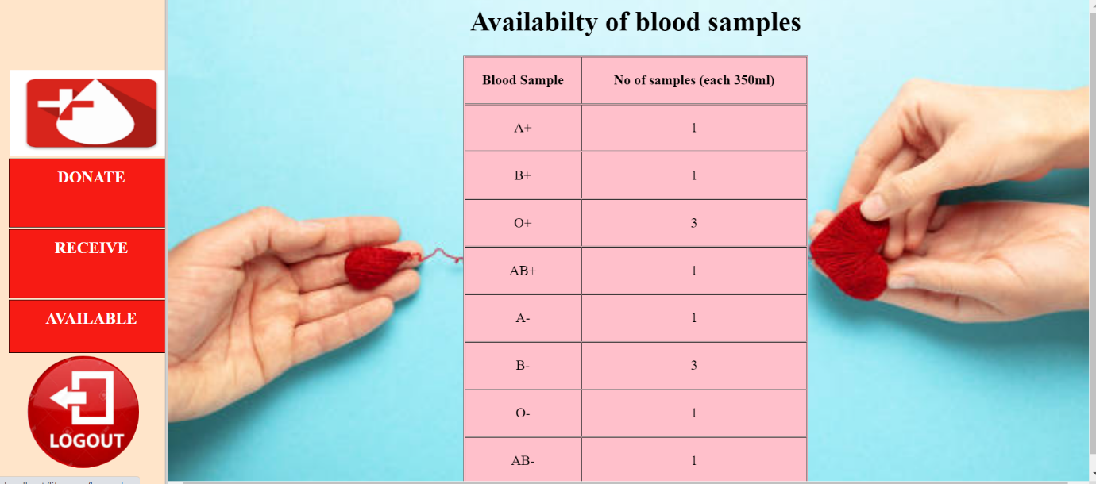

**BY:**

**198W1A0523**

**198W1A0537**

**198W1A0547**